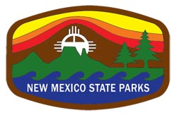
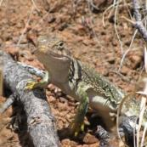
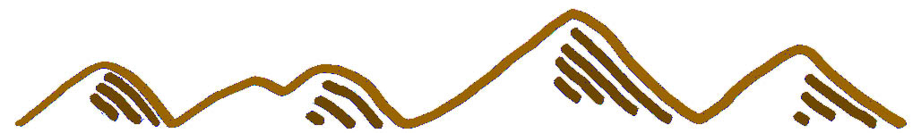
ACTIVE MEMBER (voting) SPONSORS (non-voting)
$30 Individual/Family $20 Turquoise
$50 Silver

$30 Individual / Family

SPONSORS (non-voting)
$20 Turquoise
$50 Silver

Name Email

Address Phone

City State Zip Code

I am interested in volunteering for:
Education Park Restoration Visitor Center Park Events

Other (specify)
VOLUNTEERING
MEMBERSHIP

What connections will we make?

· History & Culture
· Mining & Geology
· Stars & Darkness
· Annalemma & Time
· Tracks & Trails
· Education & Play
· Meteoroids & Sardines
· Hats & Horses
· Hiking & Biking
· Digging & Dirt
· Friends & Comfort
· Views , Views, Views
· Springs & Butterflies
· Turquoise & Shafts
· Picnics & Wildflowers
· Wind & Tarantulas
· Cameras & Wildlife
· Art & Space
Amigos de Cerrillos Hills
PO Box 460
Cerrillos, NM 87010
505-474-0196

Yes! I would like to become a ACHSP member

Join the Celebration & Become a Friend
A special thank you from all of the birds, bats, bees, cacti, lizards, mammals, plants and butterflies!
Become a founding member of the Amigos de Cerrillos Hills State Park and help us build on the years of work by the Cerrillos Hills Park Coalition, Santa Fe County Open Space and others who have dedicated time, energy and money to the enhancement and stewardship of this amazing place.
For your $30 membership as an active member, you will receive a hanging vehicle placard, transferrable between your own vehicles, which is good for unlimited day use entry to the park for one year.
Active Members will have voting privileges and are expected to participate in ACHSP events/ meetings.
AMIGOS de CERRILLOS HILLS
STATE PARK

